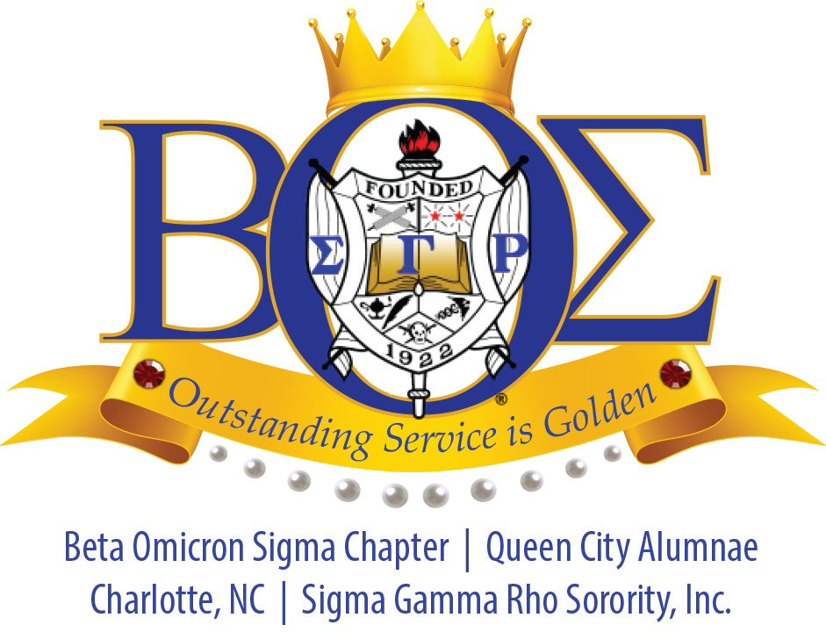
Anti-Grammateus End of Year Report 2014-2015
Soror LeShawn Dimery
Antigramm.Queencitync.sgrho@gmail.com

2014-2015 Goals Summary
My overall goal as Anti-Grammateus was to efficiently maintain and disseminate Sorority correspondences.

Goals for 2014-2015:
- Maintain accurate records – rosters, attendance and meeting minutes.
- Distribute meeting minutes within a timely manner.
- Retain permanent records of chapter and executive board meetings.

Summary of 2014-2015 Activities
- September 2014
Attended Informational Meeting at JCSU.
Attended the Rosette Cotillion Workshop

- October 2014
Participated in the Susan G Komen Race for the Cure

- November 2014
Attended Founders Day Worship Service at the Park Church and Luncheon
2014 Rosette Cotillion
Beta Omicron Sigma Informational at JCSU

- January 2015
Winter 2015 Inductions and Reception
Participated in MLK Parade
Attended Mid-Winter
- Februrary 2015
Attended CIAA Hospitality Suite JCSU
Attended Beta Upsilon Information Session

- March 2015
Youth Symposium
Attended Beta Omicron Sigma Informational at JCSU
Beta Upsilon Induction and Dinner

- April 2015
Beta Omicon Sigma InFormal
Participated in March of Dimes Walk

2015-2016 Goals
- Continue to maintain Sorority records – rosters, minutes and agendas.
- Maintain permanent records of all members within a database.
- Focus on maintaining communication with the Basileus.

